I
NTRODUCTION
:

L
ICENSING
H
OUSES IN
M
ULTIPLE
O
CCUPATION

www.glasgow.gov.uk/licensing
June 2019
A consultation to gather views on proposed changes to the licensing and regulation of taxi and private hire car vehicles.

Civic Government (Scotland) Act 1982
Consultation on future policy development of Taxi and Private Hire Car Licensing

1

Background

  - The Low Emission Zone (“LEZ”) came into effect in Glasgow City Centre on 31 December 2018. Glasgow's LEZ is being phased in and initially applies only to local service buses. On 31 December 2022 when the LEZ second phase is implemented, all vehicles entering the zone will have to meet specified exhaust emission standards. This will include all taxi and private hire car vehicles, whether licensed in Glasgow or by other local authorities.

  - The LEZ will require all vehicles entering the City Centre area to be Euro IV standard for petrol vehicles and Euro VI standard for diesel vehicles.

  - The Euro IV standard was introduced in September 2015, and all mass produced cars sold from this date must meet these emission standards.

  - From 31 December 2022, fixed penalty notices will be issued to drivers who enter the LEZ using vehicles which do not comply with the LEZ emissions standards.

1.5 The boundary of the City Centre Low Emission Zone can be viewed on an interactive map using the following link:

https://glasgowgis.maps.arcgis.com/apps/MapSeries/index.html?appid=a1cca42f50834e9ab30bec4769af1a09

Taxi and Private Hire Vehicles

2.1 Currently approximately only 24% of the taxi fleet in Glasgow are Euro VI compliant.

2.2 The age profile of taxis in Glasgow is shown as follows:-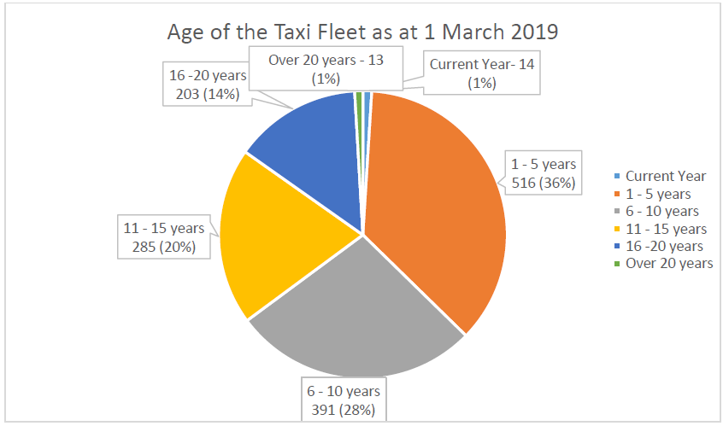

2.3 As noted above, 35% of the current taxi fleet licensed by Glasgow is more than 10 years old, and a significant proportion of those vehicles are more than 16 years of age. Therefore, when the second phase of the LEZ is implemented, a significant number of taxi vehicles will be unable to meet the exhaust emissions standards.

2.4 In relation to private hire vehicles, the Licensing Authority currently imposes a maximum age limit of 7 years on private hire car vehicles. Given the current policy in relation to the age limit of private hire cars, and the fact that all vehicles produced from September 2015 must meet the low emission standards, it is anticipated that by 31 December 2022, all private hire cars will meet the exhaust emissions standards.

Seeking Your Views

3.1 The responsibility for determining policy in relation to the inspection and testing of taxis and private hire cars and applications is delegated to the Council’s Licensing and Regulatory Committee. Further information on the Committee, including its membership and terms of reference, is available online: https://www.glasgow.gov.uk/councillorsandcommittees/

3.2 The Committee at its meeting on 17 April 2019 agreed to carry out a public consultation on proposed changes to the licensing regime of taxi and private hire car vehicles, with some of these proposals taking account of the future implantation of phase 2 of the LEZ. The proposed changes are detailed at Appendix 1.

3.3 The Committee is keen to ensure that future taxi and private hire car policy is aligned to the needs of our local communities, taxi and private hire operators and members of the public.

3.4 The Committee, as detailed above, agreed that a consultation and evidence gathering process is undertaken to seek views on the proposed changes to the licensing and regulation of taxis and private hire cars.

3.5 This consultation is an important first stage in the development of any future policy and is essential for establishing the evidential basis of any policy in relation to the licensing and regulation of taxi and private hire vehicles.

3.6 The Committee is therefore seeking your views as to whether the various proposals put forward in this consultation would be of assistance to the taxi and private hire trade in achieving compliance with the new emissions standards to be introduced in relation to the LEZ and also ensuring the condition of vehicles that are licensed.

3.7 In particular, the Committee is seeking views as to:

- Whether a policy is adopted that in determining the suitability of a taxi or private hire car in terms of section 10(2) of the Civic Government (Scotland) Act 1982 Act, all such vehicles to be used as a taxi or private hire car will require to meet the emissions standard Euro IV for petrol vehicles and Euro VI for diesel vehicles by 31 December 2022;

- Whether from 1 January 2020, the policy requiring that taxi vehicles be no more than five years of age at the date of lodging an application for a new licence or the substitution of a vehicle is removed for all applications for new and substitute taxi vehicles, subject to the replacement vehicle being a newer vehicle than that currently licensed;

- The suitability of implementing a risk based inspection program as from 1 January 2023, which would reduce the number of inspections required for newer taxi and private hire car vehicles and increase them for older vehicles; and

- From 1 January 2020, whether all advertising livery should be removed from the bodywork of a taxi aged 10 years or more prior to the annual inspection.

How to Respond

4.1 Appendix A sets out further information on each of the proposed changes to the policy.

4.2 You can respond to as many or as few of the issues as you choose depending upon your particular area of interest or experience. Where possible, please try to explain why you have a certain view, providing any evidence you have in support of that view.

4.3 Your response should be sent either:

By Post: Mairi Millar
Head of Licensing and Democratic Services
Glasgow City Council
City Chambers
George Square
Glasgow G2 1DU

By Email: LicensingEnquiries@glasgow.gov.uk

4.4 Please indicate in your response the capacity in which you are responding, for example, a member of the public, elected member, Community Council, taxi operator or private hire operator or driver.

4.5 Your response should be received by no later than Monday 29 July 2019 in order to ensure that your views are considered as part of the consultation exercise.

Next Steps

5.1 Following the consultation and evidence gathering process, the Committee will consider the views and evidence provided to it through the consultation.

5.2 All of the feedback received will be reviewed and evaluated before a final decision is made on the proposed policies.

Further Information

5.3 If you would like further information on the consultation exercise or to discuss any other aspect of the approach to Taxi or Private Hire Car Licensing, please contact:

Mairi Millar, Head of Licensing and Democratic Services

Email: mairi.millar@glasgow.gov.uk
Phone: 0141 287 5509

Confidentiality & Data Protection

6.1 The Licensing Authority will process any personal data you provide in your response appropriately in accordance with the Data Protection Act 2018 and the General Data Protection Regulation.

6.2 The Licensing Authority intends to publish a summary of responses received to the consultation exercise – this will include your name if you submit a response.

6.3 The Freedom of Information (Scotland) Act 2002 gives the public a right of access to information held by the Licensing Authority; this includes any responses we receive to the consultation exercise.

6.4 The Licensing Authority may disclose your response to third parties on request. In disclosing responses the Licensing Authority will take appropriate steps to redact personal data subject to the relevant provisions of the 2018 and 2002 Acts.

6.5 The Licensing Authority will hold your response for a period of 5 years from the date it is received. At the end of this period your response will be destroyed unless there are exceptional circumstances that require the response to be retained for a longer period.
A1. Proposals to Introduce an Emission Standard for all Taxi and Private Hire Vehicles

Section 10(2) of the Civic Government (Scotland) Act 1982 provides that a Licensing Authority shall not grant or renew a taxi licence or private hire car licence unless they are satisfied that the vehicle to which the licence is to relate is suitable in type, size and design for use as a taxi or private hire car, as the case may be, and is safe for that use.

Following the implementation of the second phase of the LEZ on 31 December 2022, it is proposed that a policy will be adopted that in determining the suitability of a taxi or private hire car in terms of section 10(2) of the 1982 Act, all such vehicles will require to comply with specified emission standards.

This would mean that the Licensing Authority could refuse an application for the grant or renewal of a taxi or private hire car or suspend an existing licence if the vehicle did not comply with the required emission standards under section 10(2) of the 1982 Act.

A2 Proposal to remove the five year age policy

The existing licensing policy in relation to taxi licences requires that the vehicle be no more than five years of age at the date of lodging an application for a new licence or the substitution of a vehicle, unless the vehicle has been previously licensed by the Licensing Authority in the last year.

This policy was introduced with the aim of maintaining the quality of the taxi fleet through preventing the transfer of older vehicles from other local authority areas to Glasgow.

During initial discussions held with taxi trade representatives regarding the exhaust emission standards which will be introduced when phase 2 of the LEZ is implemented, it was noted that they consider the requirement for vehicles to be no more than five years of age to be a significant barrier to achieving compliance. Taxi trade representatives also noted that they believed that the policy requiring vehicles to be no more than five years of age served to act as a barrier to reducing the age profile of the taxi fleet.

In the view of trade representatives, removal of this requirement would allow operators to replace older vehicles with a newer vehicle that is capable of meeting the LEZ emission standard but is more than five years old, thereby having the potential to improve the overall age of the taxi fleet in Glasgow.

It is therefore proposed that as from 1 January 2020, the five year age policy is removed for all applications for new and substitute vehicles subject to the replacement vehicle being a newer vehicle than that currently licensed.

If the 5 year age policy is removed and the new emissions standard is adopted, all operators should be aware that all vehicles would still require to be Euro VI compliant by 31 December 2022 to continue to be license to operate as a taxi or private hire vehicle in Glasgow.

A3 Proposed Changes to Vehicle Inspections

Another matter which arose during the discussions held with taxi trade representatives was that they were strongly opposed to the introduction of an upper age limit for taxis, given the higher costs associated with purchasing a taxi vehicle given the continuing requirement for a fully wheelchair accessible taxi fleet.

In order to ensure that there is a more robust system in place to assess the continuing safety and suitability of older taxi vehicles, it is proposed that, as an alternative to introducing an upper age limit for taxis, a risk based inspection programme is implemented as from 1 January 2023, which would reduce the number of inspections required for newer vehicles and increase them for older vehicles as follows:-

- Vehicles (both taxi and private hire) 3 years and under only requiring one annual inspection;

- Vehicles (both taxi and private hire) 3 years to 9 years would require 2 inspections per year; and

- Vehicles (this would only apply to taxis given the private hire car age policy) 10 years and over require 4 inspections annually.

At present all vehicles are inspected twice a year, regardless of the age of the vehicle.

If the risk based inspection regime is approved, the reduced inspections for vehicles 3 years and under would also apply to private hire car vehicles. For the avoidance of doubt, no changes are proposed to the current upper age limit of 7 years for private hire cars.

A4 Removal of Advertising Livery at Inspection – Vehicles 10 years or older.

In addition, it is proposed that as from 1 January 2020, a policy is introduced requiring that all advertising livery be removed from the bodywork of a taxi aged 10 years or more prior to the annual inspection. This will allow the Council’s Inspection Centre to be able to properly assess the condition of the bodywork of the vehicle in view of concerns regarding the increased likelihood of corrosion on older taxis.

A5 Issues for Consideration

The Committee is seeking views on the proposed policies. The Committee is particularly interested to hear views on the following:

Introduction of Emission Standard
Should a policy be introduced by the Committee determining that all such taxi and private hire vehicles should meet the emissions standard Euro IV for petrol vehicles and Euro VI for diesel vehicles by 31 December 2022? Please explain your answer.

Removal of Five Year Age Policy for Taxis
If the current five year age policy for taxi vehicles should be removed for new and substitute vehicles, subject to the replacement vehicle being a newer vehicle than that currently licensed? Please explain your answer.

Risk Based Inspection Regime

Whether you agree with a risk based inspection regime? Please explain your answer.

In relation to a risk based inspection regime, whether the frequency of inspections for the ages of vehicles above is suitable? Please explain your answer

If the frequency should be more/less than detailed above?
Please explain your answer.

Advertising Livery Removal

If you are in favour of the removal of the advertising livery for taxis aged 10 years or more to ensure the condition of the bodywork of the vehicle is thoroughly examined? Please explain your answer.

